The Adventure of Rebecca

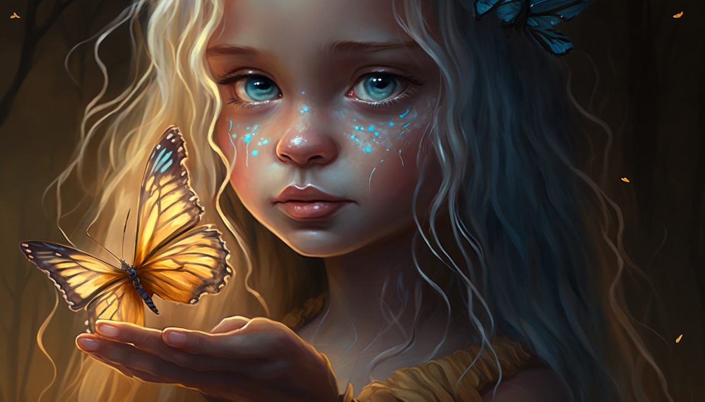

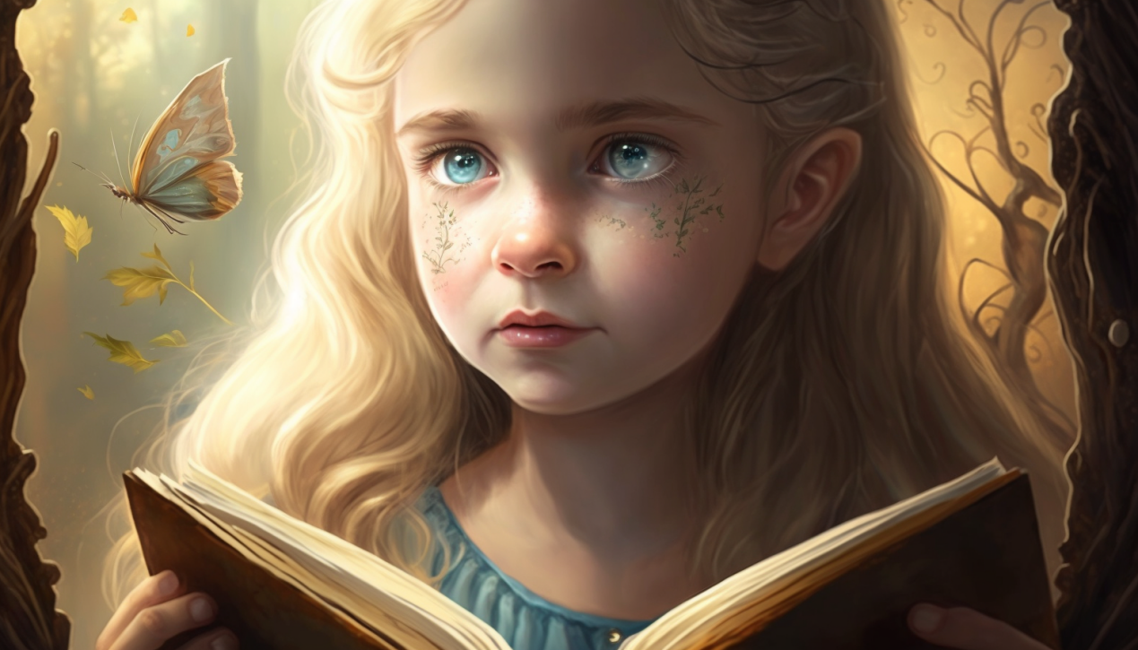

Once upon a time, there was a young girl named Rebecca, who lived in a small village near a big forest. 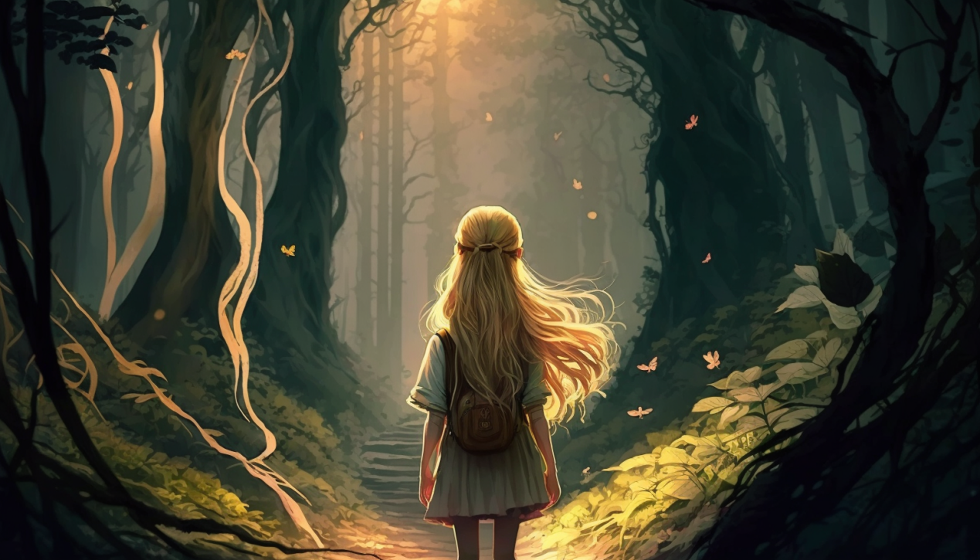Rebecca loved exploring new things. One day, while she was walking in the forest, she found a secret path.

As Rebecca went deeper into the forest, she saw unicorns, dragons, and fairies. She climbed big mountains and crossed rivers to follow her dream.

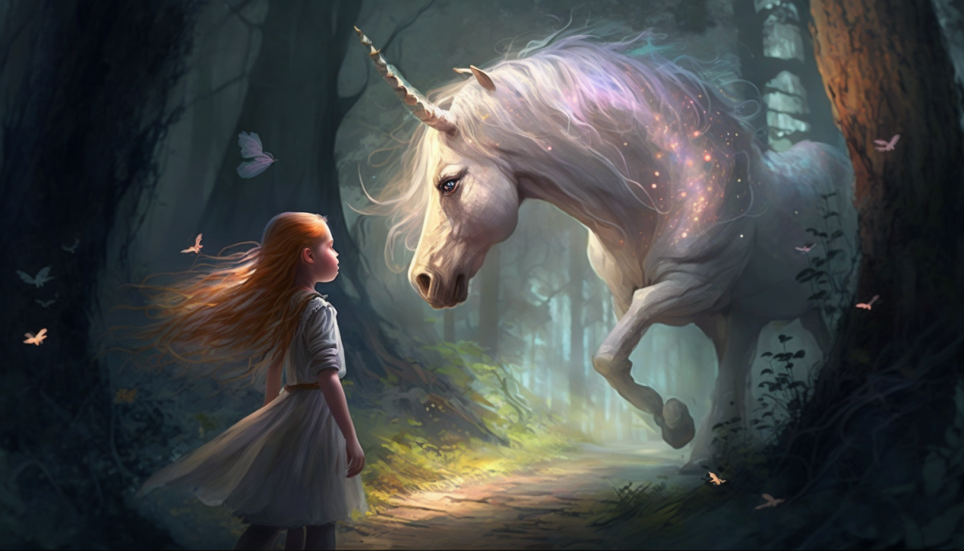

On her journey, Rebecca met some new friends who also had special skills. 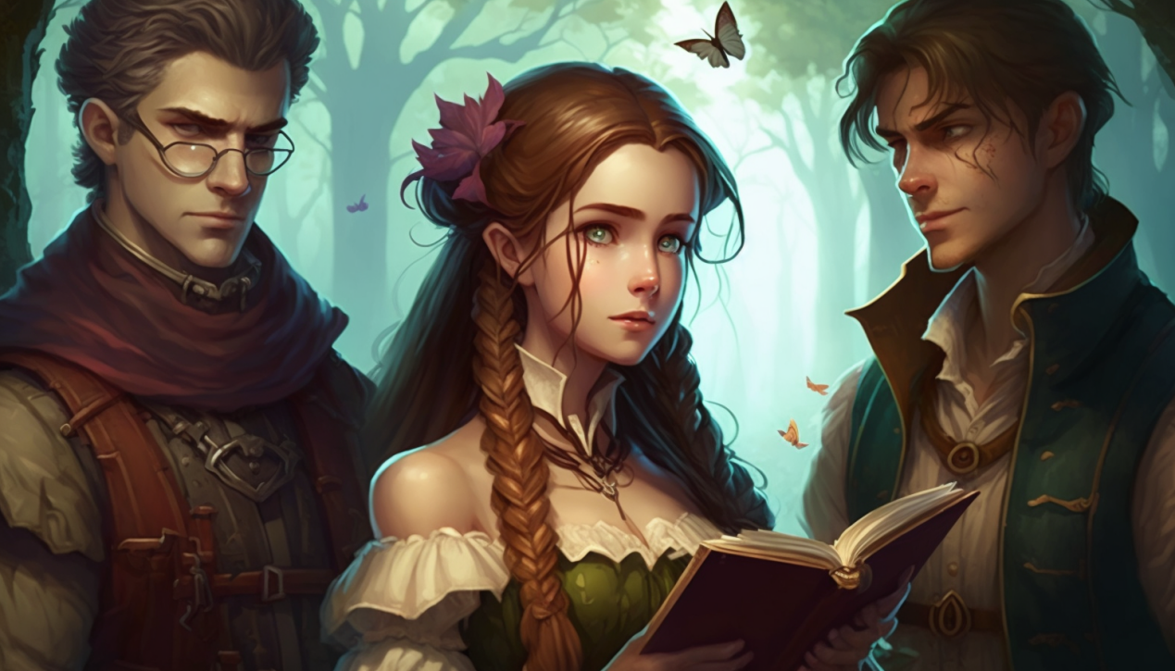

There was Alex who was good at fighting, Jack who knew a lot about the forest, and Cecillia who could do magic. They were all on an adventure to find a lost kingdom.

"What's so special about this kingdom?" she asked.

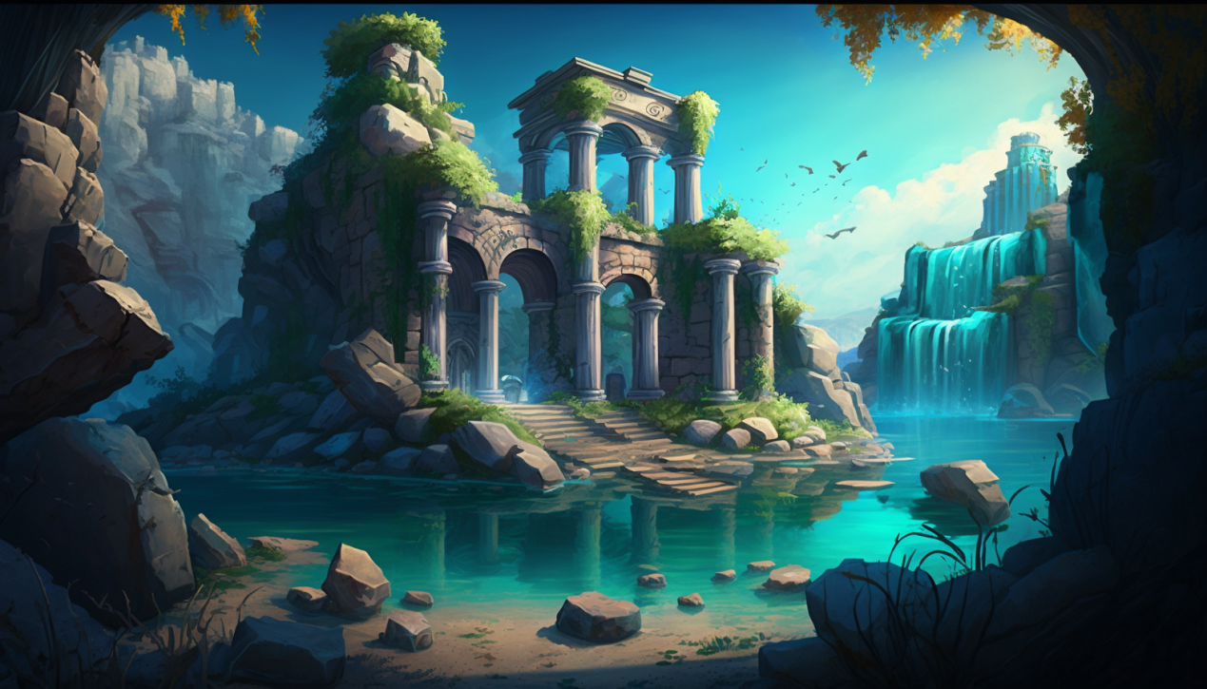

"It's said to be a place of great beauty and magic," Cecillia said. "But it's been lost to the world for centuries. We believe that there's something hidden there." 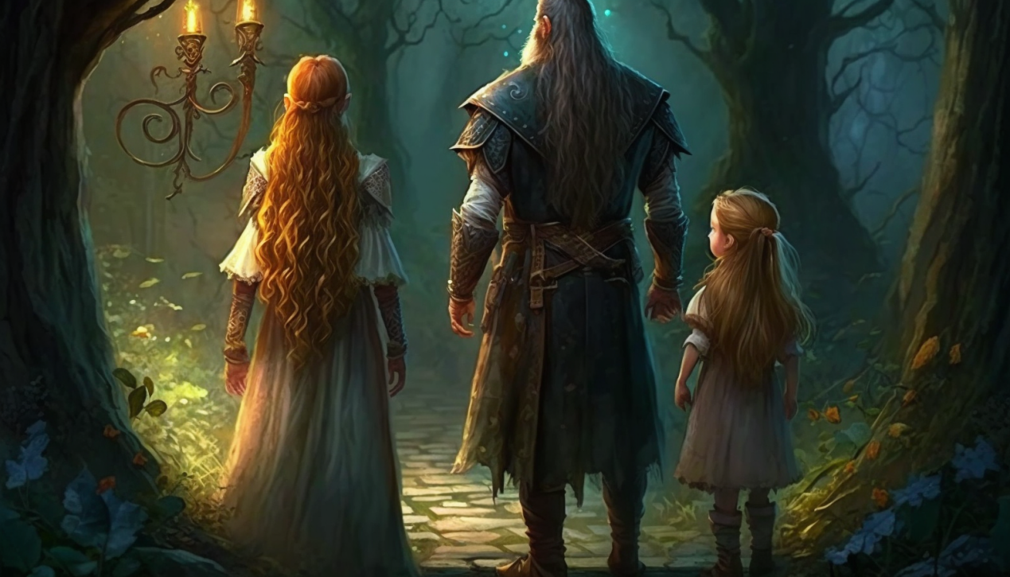

Rebecca and her friends faced many challenges but they worked together and became stronger. Finally, they found the lost kingdom with the help of an old man.

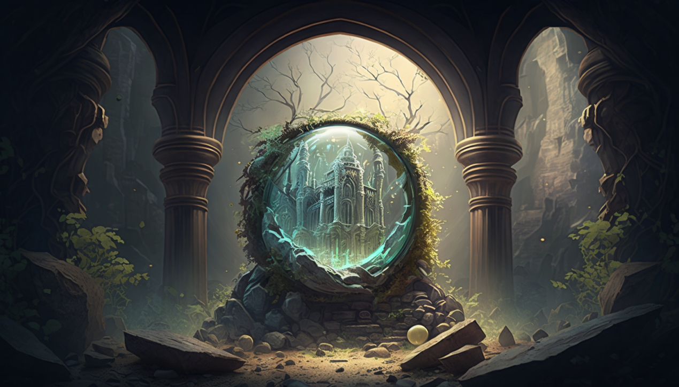

It was a magical place with lots of treasures. They discovered a powerful thing that had been lost for many years. It could change the world!

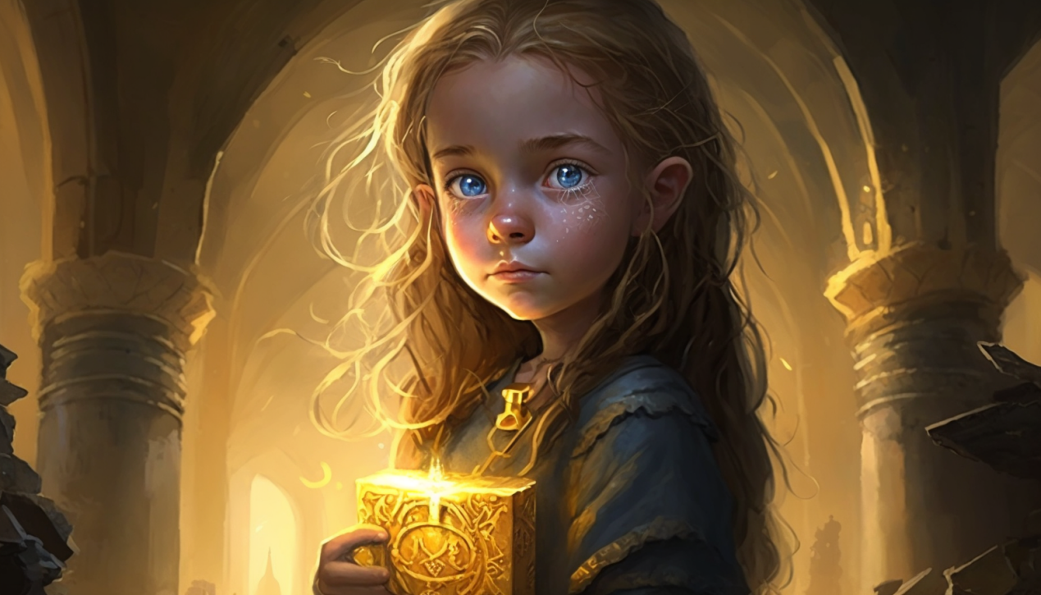

Rebecca was so happy and wanted to share her joy with her family and friends. She missed her family.

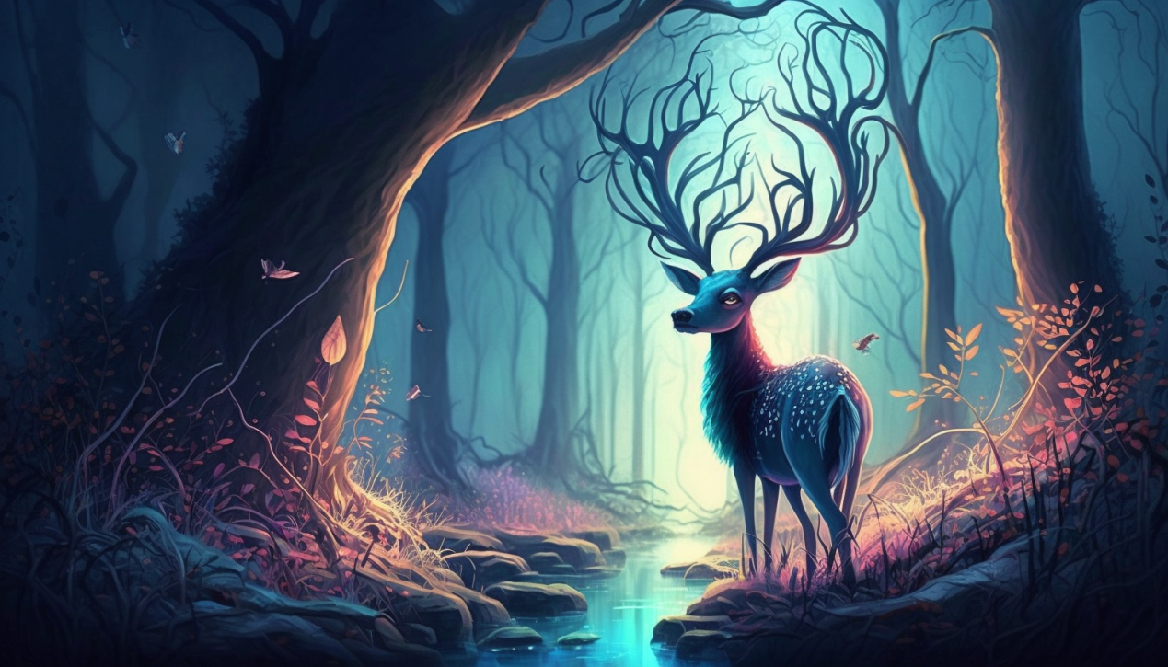

And as she walked out of the forest, she knew she learned many things on her adventure and would never forget it.

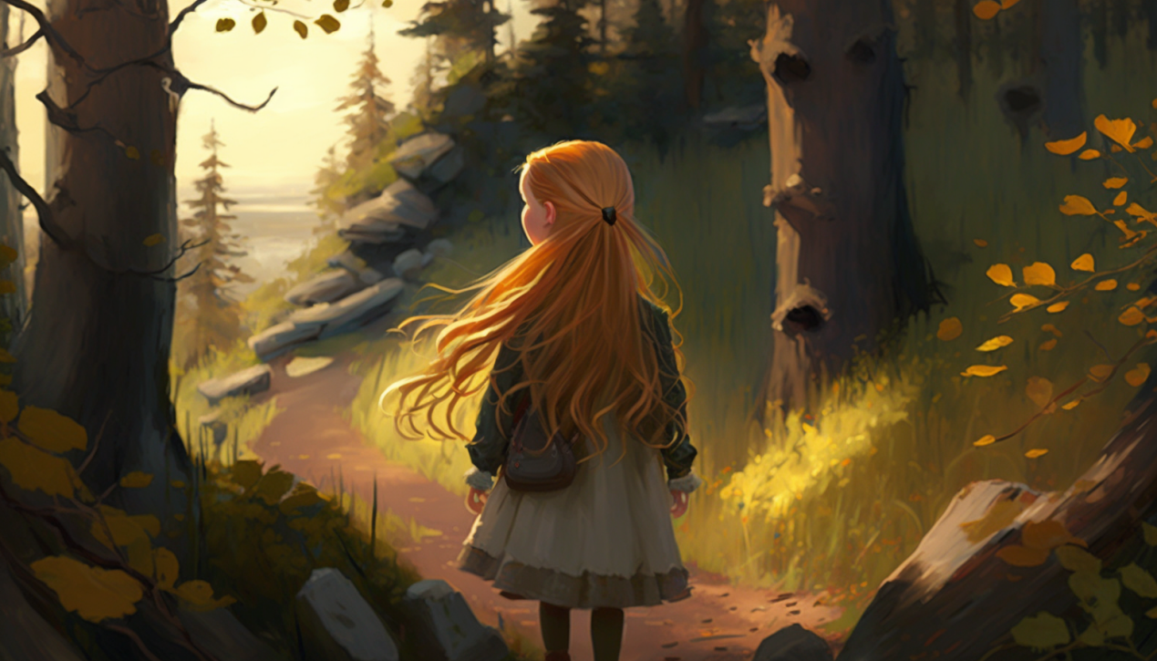Even though she had finished her adventure, she knew that there was still beauty in the world around her, and she was thankful for her experience.